Environmental Science

Name _______________________________ Block _______ Date __________

Lab: Investigating the Movement of Water in Soil and Rock- Porosity and Permeability

Objective
Investigating underground water movement by studying how the sizes of the particles
of sediment materials affect the materials’ porosity and permeability.

Background Information
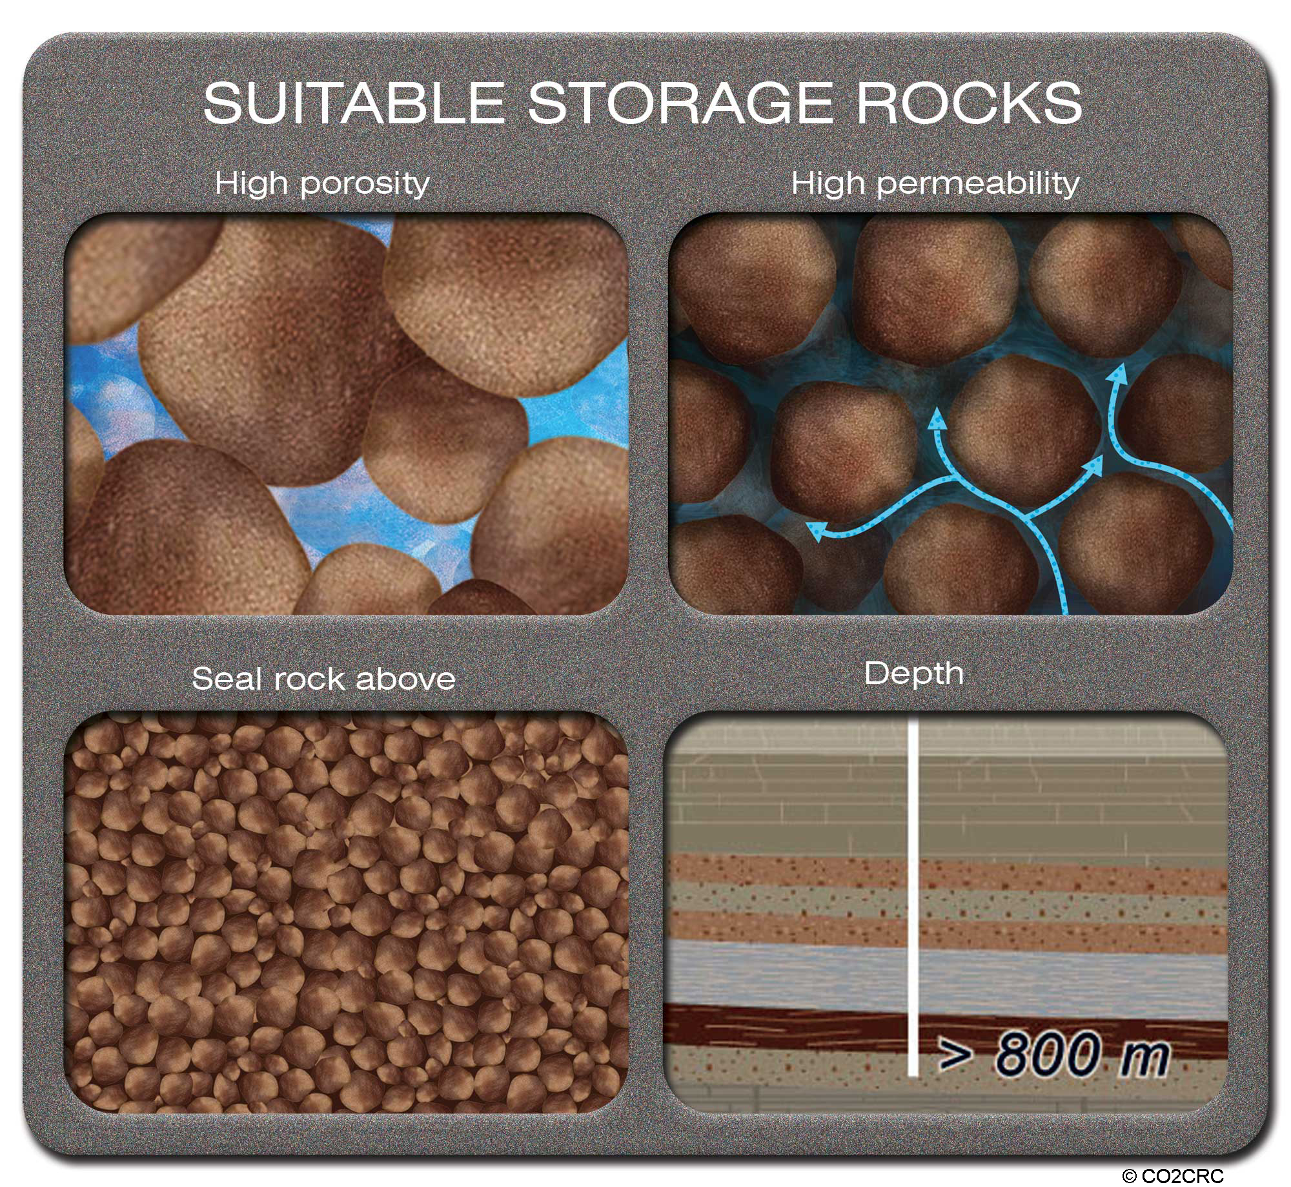
Porosity is the amount of space between the particles that make a rock or sediment. Water in an aquifer is stored in the pore spaces and flows from one pore space to another. Different earth materials have different porosities. The more porous a sediment material is, the more water it can hold. To determine porosity, measure the amount of water it takes to fill up the pore spaces of a sediment material, then divide the volume of the water used by the volume of the sediment. It is usually expressed as a percentage.

Permeability is the ability of rock or soil to allow water to flow through it. Different earth materials have different permeability. Permeability of a material can be determined by timing how long it takes a specific amount of water to flow through the material. It is measured in ml water/second. The shorter time it takes for the water to pass through the sediment material, the higher permeability the material has. This method of measuring sediment’s permeability is also called a percolation test, and it is done on land before a house is built on it.

Lab materials
Transparent column Ring stand with clamp Sediment with particles of different sizes:
100ml Graduated cylinder Funnel Size 1: ~0.5 cm
Containers for water Clock in the classroom or timer Size 2: ~1.0 cm
Size 3: ~ 3.3 cm

Lab procedure
- Assemble the transparent column on the ring stand
- Measure 100 ml of one type of the sediment with a graduated cylinder and carefully pour the material into the column.
- Let one student pinch the tube at the end of the column so that no water will leak out.
- Measure 100 ml of water with a graduated cylinder, and S-L-O-W-L-Y pour some of the water into the column using a funnel so as to JUST cover the sediment material, and then stop pouring.
- Determine how much water was poured in the column to just cover the sediment material and record this amount in the data table provided.
- Calculate the porosity of the material using the following equation. Record in the data table.
Amount of water used to just cover the material (ml)
X100%
Porosity =
Volume of the sediment in the column (ml)
( *You should do this later, after collecting all data.)

- Allow the water in the column to drain out, and leave the wet sediment material in the column. You have just finished measuring the porosity of the material, and you are going to measure the permeability of the material next.
- Measure out another 100 ml of water in your graduated cylinder.
- Pinch the tube at the bottom of the column. Using a funnel, pour all 100 ml of the water into the column filled with the sediment. Make note of the time or obtain a stopwatch. Start timing at the same time that you unpinch the tube to let the water flow out.
- Time how quickly the water drains through the sediment (stop timing when the water drops slowly down), and record the time in the data table.
- Measure and record the volume of the water that drained through the sediment.
- Determine the permeability of the sediment by the following formula:
Permeability =
Water volume passed through the sediment material (ml)
Time it took for the water to pass through (sec)
- Repeat steps 3-12 for each of the other sediment samples.
- Be sure to record all data in the data table.

PRE-LAB
1. What is porosity?
______________________________________________________________________________________________________________________________________________________

2. What is permeability?
______________________________________________________________________________________________________________________________________________________

3. Hypothesize which size sediment you think will be the most porous and why. (Write your hypothesis as an If…then…because… statement.)
______________________________________________________________________________________________________________________________________________________
___________________________________________________________________________

4. Hypothesize which size sediment you think will be the most permeable and why. (Write your hypothesis as an If…then…because… statement.)
______________________________________________________________________________________________________________________________________________________
___________________________________________________________________________

5. What is your independent variable in both investigations? __________________________

6. What is your dependent variable in each investigation?

first investigation: _________________________________________

second investigation: ______________________________________

In the first investigation you will measure porosity by pouring water over the sediment within the long plastic tube and measuring the volume of water the sediment can hold. (until the water is even with the top of the sediment)

7. List at least 2 factors you will need to keep constant in this investigation.

1. _________________________________________________________________

2. _________________________________________________________________

In the second investigation you will measure permeability by pouring water over the sediment within the long plastic tube and measuring the volume of water that drains from the bottom of the tube within 5 seconds.

8. List at least 2 factors you will need to keep constant in this investigation.

1. _________________________________________________________________

2. _________________________________________________________________

Data Table: Porosity and Permeability of Water in Various Sized Sediment Materials

Size of the sediment materials (mm) | Volume of water held by 100ml of the sediment (ml) | (Calculate)  Porosity (%) | Volume of water that passed through sediment  (ml) | Time it took to let ___ ml of water to pass through the 100 ml of sediment (sec) | (Calculate)  Permeability (ml/sec)
0.5~1.0 (average 0.75)
1.0~3.3 (average 2.2)
~3.3

POST-LAB
1. After the lab you will make a graph of the data for porosity and permeability.
- You can plot both pieces of data on the same graph.
- You will have to make sections on the x axis for each sediment size showing the range in size for each.
c. You will need a key with 2 colors, 1 for each line.

2. Draw a valid conclusion regarding the porosity of the different sized sediments. (Did porosity increase, decrease or were the results inconsistent with increasing sediment size?) Don’t forget to include specific data to support your statement, AND tell whether or not your hypothesis was supported.

______________________________________________________________________________________________________________________________________________________
______________________________________________________________________________________________________________________________________________________
______________________________________________________________________________________________________________________________________________________
______________________________________________________________________________________________________________________________________________________

3. Draw a valid conclusion regarding the permeability of the different sized sediments. (Did permeability increase, decrease or were the results inconsistent with increasing sediment size?) Don’t forget to include specific data to support your statement, AND tell whether or not your hypothesis was supported.

______________________________________________________________________________________________________________________________________________________
______________________________________________________________________________________________________________________________________________________
______________________________________________________________________________________________________________________________________________________
______________________________________________________________________________________________________________________________________________________

4. Discuss the validity of one of these investigations. Make it clear which investigation you are discussing. (Were there variables that you could not or did not control well? Was it repeated? etc.)
______________________________________________________________________________________________________________________________________________________
______________________________________________________________________________________________________________________________________________________
______________________________________________________________________________________________________________________________________________________

